Pledge Form
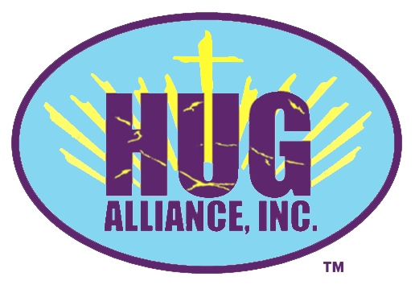 | HUG Alliance, Inc.’s mission is to provide spiritual, physical and emotional support to distressed people and communities with an underlying vision of healing through giving.
Donor Information (please print or type)

Name

Billing address

City, ST Zip Code

Phone 1 | Phone 2

Fax | Email

Pledge Information
I (we) pledge a total of $____________________ to be paid: ☐now ☐monthly ☐quarterly ☐yearly.
I (we) plan to make this contribution in the form of: ☐cash ☐check.
Gift will be matched by (company/family/foundation)
☐form enclosed☐form will be forwarded

Acknowledgement Information
Please use the following name(s) in all acknowledgements:

☐I (we) wish to have our gift remain anonymous.
Signature(s) ______________________________ |  | Date ___________
______________________________________________
Please make checks, corporate matches,  or other gifts payable to: |  | HUG Alliance, Inc.  12233 Knob Hills Road  Lynnville, Indiana 47619

Hug Alliance, Inc. is a 501(c)3 nonprofit organization. Our Federal Tax ID Number is 87-4715544.
12233 Knob Hills Road, Lynnville IN 47619 -- (812)457-4749

